KLE TECHNOLOGICAL UNIVERSITY, HUBBALLI
DEPARTMENT OF COMPUTER APPLICATIONS

GATE 0 – PROBLEM FORMULATION
EVIDENCE DOCUMENT

BLOOD BANK UNIT LEDGER
Academic Year: 2026–2027
Presented by
Yachika Suryavansi [01FE24BCA222]
Sanjana C [01FE24BCA227]
Sakshi [01FE24BCA253]
Sakshi M [01FE24BCA258]

Prepared for Gate 0 problem formulation and planning review.

Purpose and Project Boundary
This document organizes the Gate 0 – Problem Formulation evidence for the Blood Bank Unit Ledger. It covers A1 (problem statement and stakeholders), A2 (AS-IS and TO-BE workflows), A3 (scope, feasibility and risks), A4 (Integration Map v1) and B1 (theme-specific governing rule and rule-checked records).
Project boundary: the proposed system is a student prototype for recording and tracking blood-unit inventory information, including unit identification, component type, collection and expiry dates, screening/release status, current status, issue/return/quarantine/disposal transactions, search and inventory reports. It is an inventory recordkeeping aid only. It does not perform laboratory testing, make transfusion-compatibility decisions, or replace authorized clinical review and release procedures.
Safety note: All sample records and dates in this document are fictional test data. They must not be used for real blood-bank operations.

A1. Problem Statement and Stakeholders

A1.1 Problem Statement
Blood banks need accurate, traceable records for donated blood units and components, including collection date, expiry date, screening/release status, current location and final issue or disposal. Paper registers or disconnected spreadsheets can become outdated or inconsistent. Staff may spend time searching for records, duplicate entries may occur, and a unit's recorded status may not reflect a later issue, expiry or quarantine. These problems can delay inventory checks and make traceability more difficult.
The Blood Bank Unit Ledger proposes a centralized digital record system with unique unit IDs, validated data entry, status and expiry checks, search/filter functions, transaction history and inventory reports. The system will help authorized staff maintain and retrieve inventory records consistently, while clinical checks and authorization remain the responsibility of qualified personnel.

A1.2 Stakeholders and Their Needs
Stakeholder | Need / concern | How the problem affects them
Blood bank administrator | Reliable inventory summaries, controlled access and traceability. | Inconsistent records make stock reporting and auditing harder.
Blood bank technician | Accurate entry and update of unit and screening/release information. | Manual entry and repeated checking can cause delays or mistakes.
Inventory manager | Current stock, expiry and status information. | Outdated records can cause incorrect stock counts.
Hospital staff / authorized requesters | Timely availability information through approved channels. | Unclear or stale stock information can delay request handling.
Donors | Accurate handling of donation records and confidentiality. | Incorrect or poorly protected records can affect privacy and record accuracy.
Patients / recipients | Inventory information that supports timely, safe processes. | Delays or record errors may indirectly affect service delivery.
Project team / evaluators | A clear, testable system boundary and evidence. | Unclear rules make implementation and evaluation difficult.

A1.3 Problem Goal
To design a simple digital ledger that helps authorized users record, search, validate and track blood-unit inventory status, while keeping a traceable history of status changes and excluding expired, quarantined, issued or unreleased units from the available-stock view.

A1.4 Proposed Success Indicators
- A user can create a unit record with required fields and a unique unit ID.
- The system rejects duplicate unit IDs and identifies missing or invalid required fields.
- Units with expired dates, pending screening, missing release approval, quarantine or issued status are not shown as available.
- Authorized staff can search/filter records by unit ID, blood group, component type and status.
- Issue, return, quarantine and disposal changes are recorded in the transaction/status history.
- Inventory summaries reflect saved status changes and can be checked against sample records.
- Role restrictions prevent unauthorized users from changing protected records.

A2. AS-IS and TO-BE Workflows

A2.1 AS-IS Workflow (Current / Manual Situation)
- A donation or blood component is received and assigned an identification reference.
- Staff write the unit details in a paper register or a separate spreadsheet.
- Staff manually check the blood group, component type, expiry date and current stock status.
- An authorized request is received and staff search the records again to check stock.
- After issue, quarantine, return or disposal, staff update the register or spreadsheet.
- Updates may be delayed, duplicated or recorded inconsistently, leaving stock totals or status information out of date.
Typical failure points: duplicate unit IDs, incomplete records, missed expiry/status updates, slow searches, limited audit history and discrepancies between the register and actual inventory.

A2.2 TO-BE Workflow (Proposed Ledger Process)
- Authorized staff sign in and enter the unit/donation reference details.
- The system validates required fields and checks that the unit ID is unique.
- The record is saved with component type, blood group, collection/expiry dates and status fields.
- The system evaluates the record against defined inventory rules for expiry, screening, release and blocked statuses.
- Authorized staff review the information and complete required clinical and release procedures outside the software's decision-making scope.
- When a unit is issued, returned, quarantined or disposed of, an authorized user records the transaction/status change.
- The system updates inventory views and reports and preserves a traceable history of changes.

A2.3 Workflow Comparison
AS-IS (manual process) | TO-BE (proposed system)
Records may be spread across paper registers and spreadsheets. | Unit records are stored in a centralized database.
Duplicate or incomplete entries may be difficult to detect. | Required-field validation and unique-ID checks flag errors.
Expiry and status are checked manually each time. | Availability view applies defined expiry and status rules.
Searches and stock summaries may take longer. | Search/filter and inventory reports support faster retrieval.
Status updates may not be traceable. | Status changes and transactions can be logged with user/time details.
Stock discrepancies may be found late. | Updated views and checks support reconciliation; human verification remains required.

A2.4 Workflow Diagram (Text Version)
AS-IS: Donation received → Manual register/spreadsheet entry → Manual expiry/status check → Request search → Manual status update → Possible discrepancy
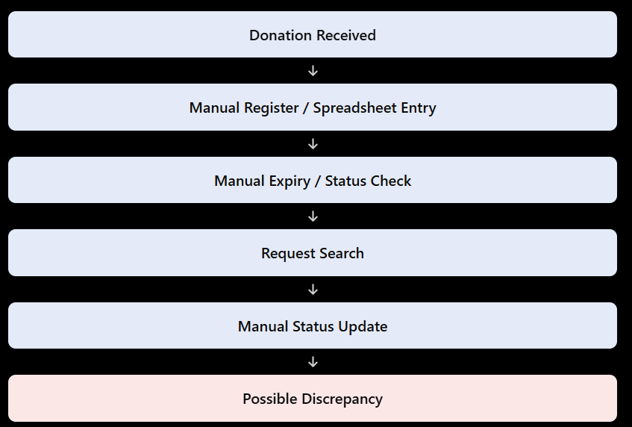
Explanation: In the existing system, blood donation details are entered manually into registers or spreadsheets. Staff manually check expiry dates, search for available blood units, and update their status. This may lead to errors, duplicate entries, and inventory discrepancies.

TO-BE: Authorized login → Validated entry / unique ID → Database record → Expiry and status-rule check → Authorized review and issue process → Transaction/audit history → Updated inventory report
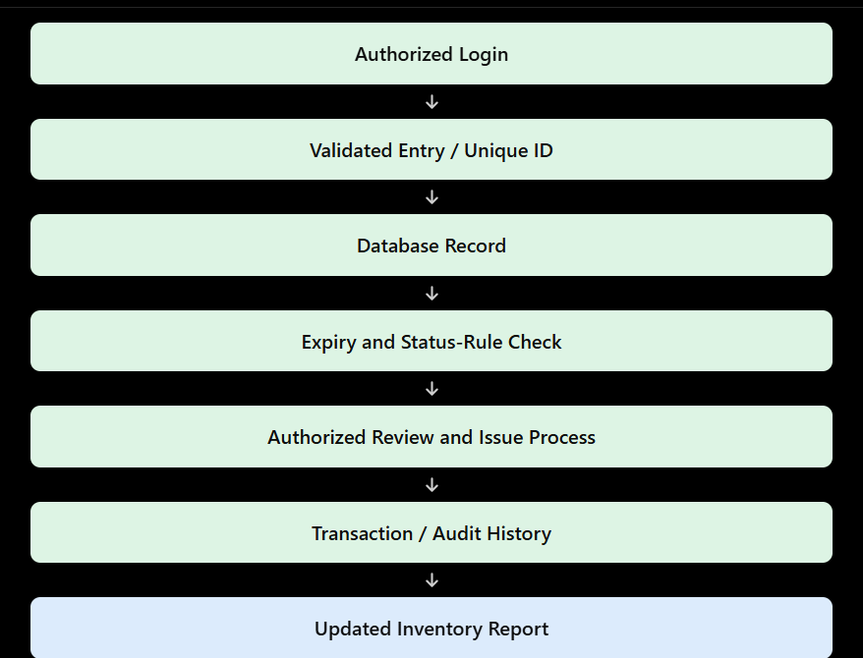
Explanation: In the proposed system, authorized staff log in and enter validated blood unit details. Each unit receives a unique ID and is stored in a database. Expiry and status checks help staff review blood availability before issuing units. Transactions are recorded in the audit history, and inventory reports are updated.

A3. Scope, Feasibility and Risks

A3.1 In-Scope Features
- Donor/donation reference records limited to the fields needed for the student prototype.
- Unique blood-unit/component ID, blood group and component type.
- Collection date, expiry date, location/reference and current status fields.
- Search and filtering of inventory records and basic available-stock summaries.
- Record issue, return, quarantine and disposal status changes.
- Basic authentication and role-based access for authorized users.
- Input validation, duplicate-ID checks and a transaction/status history.
- Basic inventory reports and testing using fictional sample records.

A3.2 Out-of-Scope Features
- Laboratory testing, clinical diagnosis or interpretation of screening results.
- Automatic transfusion compatibility approval or clinical release decisions.
- Integration with hospital, government, laboratory or blood-bank production systems.
- Real-time refrigerator temperature sensors or Internet of Things monitoring.
- Public donor appointment portal, mobile app, payments or external booking.
- Use with real patient/donor data or deployment in a live blood-bank environment without formal review, authorization and compliance checks.

A3.3 Feasibility Assessment
Feasibility area | Assessment
Technical | Feasible as a student prototype using Python, Flask, HTML/CSS and SQLite or MySQL. CRUD forms, validation, search and reports use standard application logic.
Economic | Open-source tools and existing student hardware can reduce development cost. Hosting or optional services should be assessed separately.
Operational | A simple interface with clear labels and basic staff guidance can support entry, search and status updates.
Schedule | Can be built in stages: requirements, database design, forms, validation, status logic, reports, tests and documentation.
Data / security | Access control, minimum necessary data, backups and careful handling of sensitive records are important. Any real-world use would require appropriate review and compliance.

A3.4 Risk Register and Mitigation
Risk | Possible effect | Proposed mitigation
Missing or incorrect data | Record may be unreliable. | Required fields, validation and authorized review before saving.
Duplicate unit ID | Two records may refer to the same unit. | Database uniqueness constraint and clear validation message.
Expired unit shown as available | Availability view may be misleading. | Check expiry date when displaying available stock; flag expired records.
Pending screening or release | Unit may appear available before required steps are complete. | Block availability unless required status conditions are met.
Unauthorized change | Record integrity or confidentiality may be affected. | Login, role permissions and an audit trail.
Data loss | Inventory records may become unavailable. | Regular backups and restore testing.
Stock count mismatch | Summary may not match the recorded transactions. | Record status changes consistently and reconcile reports against unit-level records.
Clinical rule misunderstood | Software may be mistaken for a clinical decision-maker. | State clearly that the ledger is an inventory aid; authorized personnel follow approved procedures.

A4. Integration Map v1 (Five Course Areas)
The five course-area labels below are a proposed mapping based on the technologies and methods used in this project. If the instructor supplied official names for the five course areas, replace these labels with those exact names.
Proposed course area | Where it appears in the project | Evidence / deliverable
1. Python Programming | Validation, status rules, stock calculations, search/filter logic and issue processing. | Python modules, functions and test cases.
2. Database Management Systems | Donor/donation reference, blood-unit and transaction tables; keys, constraints and queries. | ER diagram, schema, sample data and SQL queries.
3. Web Technology / User Interface | Login, unit-entry forms, inventory search, status display and reports. | Page screenshots, form validation and route list.
4. Cybersecurity / Information Security | Authentication, role-based access, input validation and confidentiality controls. | Access-control tests and examples of restricted actions.
5. Software Engineering | Requirements, workflows, scope, feasibility, risk analysis, test plan and version control. | This evidence document, workflow diagrams, test results and project repository history.

A4.1 Integration Flow
User interface (HTML/CSS) → Flask routes → Python validation and inventory/business logic → database access layer → unit and transaction records → response returned to the interface. When an authorized status change is saved, the system updates the relevant inventory view and retains the transaction/status history.

A4.2 Integration Dependencies
- The database schema must include the fields needed by forms, inventory rules and reports.
- The unique unit ID and status values must be consistent across the interface, Python logic and database.
- Expiry and availability checks must use the same defined rule wherever available stock is displayed.
- Role permissions must be enforced by the backend, not only hidden in the user interface.
- Reports must use the latest saved unit and transaction records.
- Testing should use fictional data and remain possible without access to a real blood-bank system.

B1. Theme-Specific Evidence – Rule-Checked Records Register

B1.1 Governing Rule (One Sentence)
A blood unit must not be displayed as available for issue unless it has a unique traceable ID, is within its valid expiry period, has the required screening and release status recorded, and is not issued, quarantined or otherwise blocked.

B1.2 Record That Could Be Decided Incorrectly
The record at risk is the Blood Unit Availability and Issue Status Record. For example, a register may still show a unit as “Available” after it has expired, been issued or placed in quarantine. If the system does not check the current status, the availability display could be wrong. The project therefore needs consistent validation and clear status-update rules.

B1.3 Rule-Check Register
Check | Rule / validation | Evidence to retain | Failure response
R1: Unique ID | Each unit record must have a unique, non-empty ID. | Unit ID and validation result. | Reject duplicate ID and show an error.
R2: Required fields | Required fields must be present and valid before saving. | Submitted fields and validation result. | Do not save an invalid record; identify missing fields.
R3: Expiry | A unit past its recorded expiry date must not appear available. | Unit ID, expiry date, evaluation date and decision. | Flag as expired and exclude from available-stock view.
R4: Screening / release | Required screening and release status must be recorded as complete/approved before availability. | Recorded statuses and decision result. | Block availability when pending or not released.
R5: Blocked status | Quarantined, issued or disposed units must not appear available. | Current status and transaction history. | Exclude from availability view and preserve history.
R6: Status update | An authorized issue/return/quarantine/disposal action must update the unit status consistently. | User/action/time and before/after status. | Show failure and avoid reporting a stale update as successful.
R7: Access control | Only authorized roles may make protected changes. | User role and access-test result. | Deny the action and record the event where supported.

B1.4 Illustrative Rule-Check Sample
The following records are fictional examples created only to demonstrate the rule. Dates and statuses are not clinical guidance.
Demo unit ID | Group / component | Expiry (demo) | Screening / release | Recorded status | Expected system decision
BBU-DEMO-001 | B+ / Packed red cells | 2027-01-15 | Passed / Released | Available | Eligible for availability view, subject to authorized clinical checks.
BBU-DEMO-002 | O+ / Whole blood | 2026-01-10 | Passed / Released | Available (stale) | BLOCK: expired.
BBU-DEMO-003 | A- / Platelets | 2026-11-01 | Pending / Not released | Available (stale) | BLOCK: required status incomplete.
BBU-DEMO-004 | AB+ / Plasma | 2027-02-10 | Passed / Released | Quarantined | BLOCK: quarantined.
BBU-DEMO-005 | O- / Packed red cells | 2027-03-20 | Passed / Released | Issued | BLOCK: already issued.

B1.5 Acceptance Tests
Test ID | Condition | Expected result
T01 | Unique ID, valid expiry, required status complete, current status available. | May appear in availability list, subject to authorized clinical checks.
T02 | Expiry date is in the past. | Must not appear as available; flagged as expired.
T03 | Screening is pending or release is not approved. | Must not appear as available.
T04 | Current status is quarantined. | Must not appear as available.
T05 | Current status is issued or disposed. | Must not appear as available; history is preserved.
T06 | Duplicate unit ID is submitted. | Record is rejected with a validation message.
T07 | User without required permission attempts a protected update. | Update is denied.

Gate 0 Review Checklist
- A1: Problem, stakeholders, problem goal and success indicators are stated.
- A2: AS-IS and TO-BE workflows and their comparison are documented.
- A3: In-scope/out-of-scope features, feasibility and risks are recorded.
- A4: Five course-area connections, integration flow and dependencies are mapped; official course-area labels are confirmed.
- B1: Governing rule, record at risk, rule-check register and acceptance tests are defined.
- Project boundary is consistent: the system is an inventory-recording aid and does not replace clinical testing, compatibility checks or authorized release.
- Sample records are clearly marked as fictional and are not represented as real operational data.
- Project title, team details, mentor details and submission date are completed before submission.

References and Evidence Note
This planning document describes a student prototype and does not certify that the software meets clinical, regulatory or operational requirements. Before any real-world use, the design would require review against applicable blood-centre standards, privacy/security requirements and authorized clinical procedures.
Suggested background references for the project team to verify:
- Ministry of Health and Family Welfare, Government of India, National Standards for Blood Centres: https://clinicalestablishments.mohfw.gov.in/sites/default/files/2023-03/1491_0.pdf
- World Health Organization, guidance on documentation and records: https://iris.who.int/bitstream/handle/10665/376096/9789240086579-eng.pdf
Implementation evidence to add later (only when available): genuine screenshots from the running application, database table/query outputs, and results from executing the acceptance tests. Do not claim that a test passed unless it has actually been run.

